Bank Management System
Software Requirements Document
V 1.0


 | Prepared By | Reviewed by | Approved By
Name | Mahalakshmi
Role | Team member | Project Leader/ Team Leader/ Team Member | Project Manager/ Team Leader
Signature | Maha
Date | 13/11/2014

Table of Contents
1.0 Introduction 3
1.1 About this document 3
1.1.1 Purpose & Scope of the document 3
1.1.2 Intended Audience 3
1.2 About the Software System 3
1.2.1 Purpose 3
1.2.2 Scope of the system 4
1.2.3 Exclusions 5
1.2.4 System Perspective 5
1.2.5 System diagram 5
1.2.6 Architecture diagram 5
1.2.7 System Environment 7
1.2.8 User Characteristics 7
1.2.9 Impact of the System 8
1.2.10 Assumptions, Dependencies, Risks / Constraints 8
1.2.11 Design Constraints 8
2.0 System Requirements 9
2.1 Functional Requirements 9
2.1.1 Home Module 9
2.1.2 Registration Requirement – Customer 10
2.1.3 Login – Customer 14
2.1.4 Customer 15
2.1.4.1. Apply Loan Page 15
2.1.4.2 Transactions Page 17
2.1.4.3 Account Updation Page 18
2.1.4.4 Bank Statement Generation Page 20
2.2 Nonfunctional Requirements 21
2.2.1 UI Requirements: Inn 21
2.2.2 Performance Requirements: Pnn 22
2.2.3 Installation, Deployment & Operational Requirements: Onn 22
2.2.4 Maintainability & Portability Requirements: MPnn 22
2.2.5 Security Requirements Snn: 22
3.0 Requirements / Use Case Summary Table 23
4.0 Make /Buy analysis 24
4.1 Reusable components 24
5.0 Annexure 24
6.0 Change Log 24

Introduction

About this document

Purpose & Scope of the document
The purpose of the software requirements document is to systematically capture requirements for the project and the system “Bank Management System” to be developed. Both functional and non-functional requirements are captured in this document. It also serves as the input for the project scoping
The scope of this document is limited to addressing the requirements from a user, quality, and non-functional perspective. It is recommended that design aspects are not added in this document

Intended Audience
Project Team

About the Software System
The client would like to develop an independent application Bank Management System (BMS) application in order to automate the process of managing the activities of bank like opening an account, transaction, apply loan etc.
The following section will cover aspects related to Bank Management System.

Purpose
BMS is a system used for managing the activities of bank like opening an account, transaction, apply loan etc.
The following are the few important modules in the system
- Customer Registration
- Apply Loan
- Transaction
- Update Profile
- Bank Statement Generation

Scope of the system
The scope of the system is explained through its modules as follows
- Customer Registration – used by customers to register the details of self-information into the system. The system stores the details of the customer in the system along with the account details.
- Apply Loan - will be used by registered users to apply loan into the system. The system stores the loan details in the system along with the account details.
- Transaction - will be used by registered users to make Transactions on their accounts. The system stores the details of the Transaction types Deposit, Withdrawal, Loan EMI debit
- Update Profile - will be used by registered users to update the details of account holder into the system. The system should update the details of the account holder in the system along with the account details.
- Bank Statement Generation - used by customers to view the bank statement.
Use Case Diagram
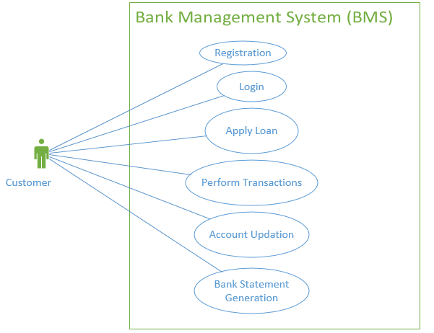

Exclusions
The system will operate only on the modules discussed above and will not include any additional functionality.

System Perspective
Bank Management System is an independent software system developed to manage the activities like Customer Registration, Apply Loan, Transaction, Update Profile, Bank Statement Generation using the Java/ Dotnet architecture.

System diagram
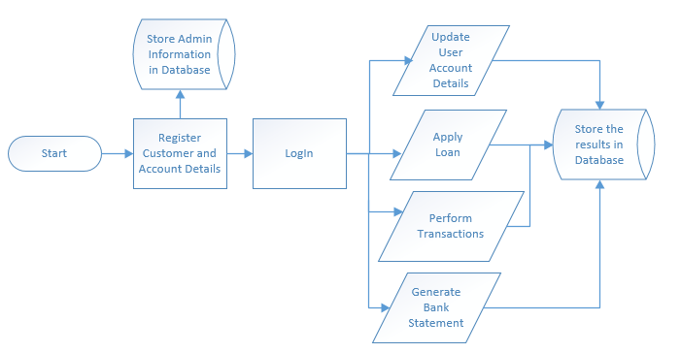

Architecture diagram

Physical Architecture:
A physical architecture is an arrangement of physical elements, (system elements and physical interfaces) that provides the designed solution for a product, service, or enterprise. It is intended to satisfy logical architecture elements and system requirements. Bank Management System follows a three layered architecture namely presentation layer, business logic layer and data access layer.
- Presentation Tier is the tier in which the users interact with an application. Presentation Tier contents Shared UI code, Code Behind and Designers used to represent information to user.
- Business Tier is mainly working as the bridge between Data Tier and Presentation Tier. All the Data passes through the Business Tier before passing to the presentation Tier. Business Tier is the sum of Business Logic Layer, Data Access Layer and Value Object and other components used to add business logic.
- Data Tier is basically the server which stores all the application’s data. Data tier contents Database Tables, XML Files and other means of storing Application Data.
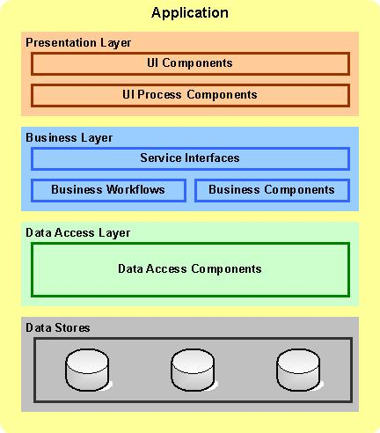

Logical Architecture:
The Logical Architecture defines the Processes (the activities and functions) that are required to provide the required User Services. Many different Processes must work together and share information to provide a User Service. The Processes can be implemented via software, hardware, or firmware. The Logical Architecture is independent of technologies and implementations.
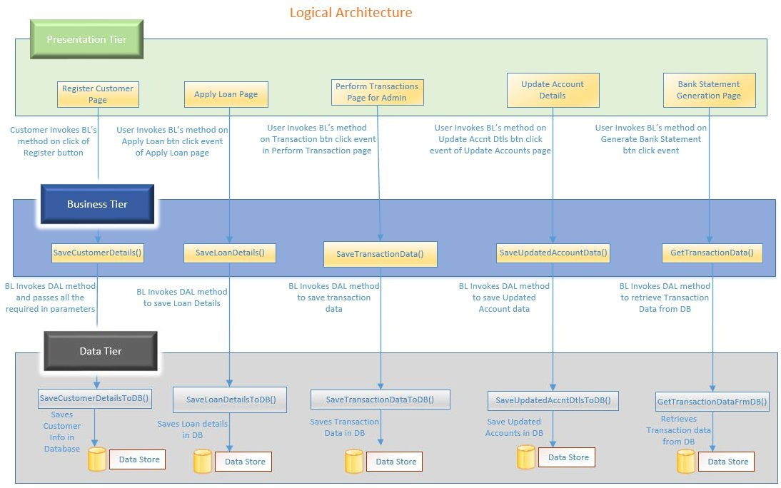

System Environment
Bank Management System application will be operated from the client server with parallel processor support. When a user connects to the Web Server, the Web Server will interact with the Database after processing the business logic to transfer data to and from a database.
- Java/J2EE or .NET Framework application deployment.
- My Sql/Sql server database for data storage

User Characteristics
The application should be user friendly; hence the user should not need any software and hardware knowledge. The user may be new to the client products having never used them before.
The types of users likely to use the system are as follows,
- Client
- Delivery Assurance Group, Process Engineering group
- Developers, testers, other associates in the project

Impact of the System
This is a new product which is developed for internal users. Expected impact of the product is to automate existing manual processes in order to make them more efficient and cost effective.

Assumptions, Dependencies, Risks / Constraints
Assumptions:
The Admin should be registered with in the system.
Dependencies:
If there is any similar Bank Management process required for other applications of the same client, this system should be able to accommodate such a reusability dependency.
Risks:
If there is any failure in Bank Management process, the system should be able to handle such a financial risk.

Design Constraints
Application should have single login feature. Login functionality should be the welcome feature for the application.
Only administrator can access the application.
None of the application features can be accessed without login.

System Requirements

Functional Requirements

Home Module
Bank Management System  Req-2.1.1 | Home Page
Functional Requirements | When the users enter the following link http://localhost/BankManagementSystem in the browser, Home page appears which will have a short welcome message; a brief introduction to the purpose of the Bank Management System, the user can choose appropriate options.  Under home page, we need below interface.
Home page Interface Requirements | - Customer  - Admin  - About Us  - Contact Us

Registration Requirement – Customer

Bank Management System  Req-2.1.2 | Customer - Registration
Functional Requirements | When the Customer clicks on the registration link, it should re-direct to registration form where he fills some of the basic attributes/fields as mentioned below in requirement;  Password, First Name, Last Name, Age, Gender (Male or Female) ,Contact Number  E-mail, Address, Zip code, City.  Any given point of time, the user can deselect all or can go to home page by the clicking home.
User Interface Requirements | This should capture the following fields  - Name – Name of the customer.  - Username – Customer login name.  - Password – Password for login  - Re-type Password – For entering the password.  - Guardian Type – Represents the Guardian Type  - Guardian Name – Represents the Father/Husband name.  - Address – Represents the address of the person.  - Citizenship – Represent the customer citizenship  - State – Represent the state based on the country.  - Country – Represent the country.  - Email Address – Represents the email address.  - Gender- Represents the Gender.  - Marital Status – Represents the marital status.  - Contact no – Represent the customer contact number.  - Date of Birth- Represents the customer DOB in DD/MM/YYYY format.  - Registration Date- Represents the customer registration Date which is automatically populated from the system current date  - Account type – Represents the type of account  - Branch Name –Represents the branch name  - Citizen status – Represents the citizen status  - Initial Deposit Amount - Represents the first deposit amount.  - Identification Proof Type – Represents the identification proof  - Identification Document No. – Represents the identification document number.  - Reference account holder name – Represents the nominee account holder name  - Reference account holder acc. No. – Represents the nominee account holder account number.  - Reference account holder address- Represents the nominee account holder address.
Trigger | AIP Admin/User should register into the system before he logs in to the application
Post Conditions | The data will be inserted into the system and a unique id will be generated
Success End Condition | Display the successful registration message with the generated unique id
Failed End Condition | The system should throw an error message if one of the validations is wrong.
Steps & Actions | - Customer accesses the Register user functionality.  - System should display all the necessary fields in the screen.  - Customer id should be generated automatically during the time of registration.  - Customer id should be in the format of ‘R-XXX’.XXX should be numeric of 3 digits.  - PAN number must be alpha numeric and no special characters are allowed, no space is allowed. PAN number must be 12.  - No two customers can have same PAN number.  - If the PAN number exists then system should give error like “Customer with PAN number <PAN Number> exists in the system”.  - The minimum age & maximum age limit for the opening account is 18 & 96.  - Based on the DOB, age will be calculated and senior citizen/ citizen/minor will be identified.  - Activation date can be calculated based on the registration date.  - On registering, the system needs to check for initial deposit amount based on the accounts type.  - System needs to store the customer details into the system.  - Identify the country id based on the country and state details as follows: This could be changeable in the system at any point of time.  - Identify the initial deposit amount for Indian citizen based on the account type as follows: This could be changeable in the system at any point of time.  - Identify the initial deposit amount of savings account for NRI customer based on the country. This could be changeable in the system at any point of time.  - Identify the status of the citizen and interest based on the age. This could be changeable in the system at any point of time.  - Interest can be identified based on the citizen status as follows: This could be changeable in the system at any point of time.  - Identify the IFSC code based on the bank name and branch name as given below: This could be changeable in the system at any point of time.  - Calculate the activation date based on the registration date: This could be changeable in the system at any point of time.  Activation date = registration date+5  20. Password and Re-type password must be same. Otherwise show proper error message.
  Country Id | Country | State
  C01 | India | TamilNadu
  C02 | India | Kerala
  C03 | India | Karnataka
  C04 | India | Andhra Pradesh
  C05 | UK | Scotland
  C06 | USA | New Jersey
  C07 | Italy | Rome
  Account Type | Initial Deposit Amount
  Saving | 5000
  Salary | 0
  Country | Initial Deposit Amount for savings account
  India | 5000
  UK | 14000
  US | 15000
  ITALY | 13000
  AGE | Status
  <18 | Minor
  >18 to <=60 | Normal
  >60 | Senior
  Status | Interest (in %)
  Normal | 10%
  Senior | 15%
  Branch name | IFSC code
  VALASARAVAKKAM | HDVL0012
  TNAGAR | HDTN0013
  TNAGAR | SBITN0123
  SAIDAPET | SBISD0113
  TNAGAR | ICITN0232
  PERUNGUDI | ICIPG0242
  TNAGAR | AXTN0342
  NUMGAMBAKKAM | AXNU0356
Business Rules & Validations | - The customer name should contain only alphabets and space.  - All fields are mandatory.  - The customer id should be automatically generated by the system and format should be ‘R-XXX’.XXX should be numeric of 3 digits.  - Contact number should be 10 digits.  - Email id should contain @ and. symbols.  - Based on the country, state has to be populated automatically.  - Account number will be generated automatically and should be a numeric of 16 digits.  - DOB(Date of Birth) should not be less than system date  - Age should be greater than 18.  - Account Number should be generated automatically and should be a numeric of 16 digits  - Registration Date should not be lesser than system date.  - Activation date can be calculated based on the registration date(i.e: registration date+5)  - Identify the citizen status based on the age which in turn, can be calculated based on the DOB.  - Identify the interest rate based on the age calculated from DOB.  - Reference: account number should be numeric of 16 digits  - Reference: account holder name should contains only characters and space  - Initial deposit amount should be numeric greater than zero and should contains only positive values  - Account type can be salary/savings.  - Based on the account type and citizenship, initial deposit amount will be varying.  - At the time of registration, the following task needs to be done:  - Retrieve the country id for the given country and state.  - Activation date will be calculated.  - Retrieve the citizen status based on the age (calculated based on the DOB).  - Retrieve the IFSC code based on the bank name and bank branch.  Update the above customer details automatically into the database.

Login – Customer

Bank Management System  Req-2.1.3 | Customer - Login
Functional Requirements: | When the user enters the following link http://localhost/BankMangementSystem in the browser, the Login page will provide the features like, Login id and Register for free.  Below are the fields:  - Login id  - Password
User Interface Requirements | Login id – Represents the Login id.  Password - Represents the Password for the Admin/User  Login Button – Represents the Login Button on click of which user validation should occur.
Trigger | Customer should log in to the application
Post Conditions | If the login successful then users should be able to view their respective Home Page.
Success End Condition | Display the success message “Login is Successful.”
Failed End Condition | The system should throw an error message if the given credentials are invalid.
Steps & Actions | System should validate the Username and Password.
Business Rules & Validations | Username and Password are Mandatory fields.

Customer

Apply Loan Page
Bank Management System  Req-2.1.4.1 | Apply Loan Page
Functional Requirements | - When the Customer logs in, he should be able to apply for loan.  Any given point of time, the Customer should have the option to go for home page, by clicking home.
User Interface Requirements | This should capture the following fields  - Loan Type – Represents the Loan Type  - Loan Amount – Represent the Loan Amount  - Loan Apply Date – Represent the Loan Apply Date.  - Loan Issue Date – Represent the Loan Issue Date.  - Rate Of interest – Represents the Rate Of interest.  - Duration of the loan - Represents the tenure for which the loan is applied for.  Based on the selected loan type either education loan details or personal/housing loan details should be displayed on the same screen.  3.1. Educational details  - Course Fee – Represents the Course Fee  - Course – Represents the Course  - Father Name – Represents the Father’s Name  - Father Occupation – Represents the Father’s Occupation  - Father’s Total Exp – Represents the Father’s Total Experience  - Father’s Exp with Current company - – Represents the Father’s Experience with Current company  - Ration Card No – Represents the Ration Card Number  - Annual Income – Represents the Annual Income  3.2. Personal/Housing details  - Annual Income – Represents the Annual Income  - Company Name – Represents the Company Name  - Designation – Represents the Designation  - Total Exp – Represents the Total Experience  - Exp with Current company – Represents the Experience with Current company
Trigger | Registered users trigger the functionality once he/she needs loan from the bank.
Pre-Conditions / Assumptions | The user must be a registered user with some savings or salary account.
Post Conditions | The loan details will be generated and stored along with the customer details.
Success End Condition | On success a message should be displayed “Loan applied successfully”
Failed End Condition | If the customer’s search criteria do not match with the details stored in the system a message will be displayed to the user “Search Found No Relevant Results”.
Steps & Actions | - System should display all the necessary fields in the screen.  - Loan id should be generated automatically during the time of registration.  - Loan id should be in the format of ‘L-XXX’.XXX should be numeric of 3 digits.  - System needs to go to either Educational screen or Personal/housing screen based on loan type.  - System needs to store the loan details into the system.  - Identify the initial deposit amount for Indian citizen based on the account type as follows: This could be changeable in the system at any point of time.  - EMI should be calculated by using the following formula and updated in the table  The formula for calculation of EMI given the loan, term and interest rate is:  EMI = (p*r) (1+r)^n  _______  (1+r)^n - 1  p = principal (amount of loan), r = rate of interest per instalment period, i.e., if interest is 12% p.a. r = 1, n = no. of instalments in the tenure, ^ denotes whole to the power. Alternatively, the reader can use `Calculate EMI function' in EXCEL spread sheet.
Business Rules & Validations | - The Account holder name should contain only alphabets and space.  - All fields are mandatory.  - The Loan id should be automatically generated by the system and format should be ‘L-XXX’.XXX should be numeric of 3 digits.  - Loan Account number will be generated automatically and should be a numeric of 16 digits.  - Loan apply date should not be lesser than system date.  - Loan issue date should be greater than or equal to system date.  - Loan has to be issued within 30 days from the loan apply date  - EMI should be calculated by using the following formula and updated in the table  The formula for calculation of EMI given the loan, term and interest rate is:  EMI = (p*r) * (1+r)^n / (1+r)^n - 1  p = principal (amount of loan), r = rate of interest per instalment period, i.e., if interest is 12% p.a. r = 1, n = no. of instalments in the tenure, ^ denotes whole to the power. Alternatively, the reader can use `Calculate EMI function' in EXCEL spread sheet.  - Account holder name should contains only characters and space  - Initial deposit amount should be numeric greater than zero and should contains only positive values  - Loan type can be Personal or Housing or Educational.  - Duration of Loan can be 5,10,15,20 years only.

Transactions Page
Bank Management System  Req-2.1.4.2 | Customer – Transactions Page
Functional Requirements | - When the Customer logs in, he should be able to perform Transactions on his account.  - Any given point of time, the Customer should have the option to go for home page, by clicking home.
UI Interface Screen | This should capture the following fields  - A/c Number – Represents Account number of the A/c holder.  - A/c Name – Represents the Account name.  - A/c Type – Represents the Account type.  - Transaction id – Represents the Transaction id.  - Transaction Type – Represents the type of transaction.  - Transaction Date – Represents the transaction date.  - Amount – Represents the amount to be debited or credited  - Display text below the text box mentioning “Enter Deposit or Withdrawal amount. This is not applicable for Loan EMI debit”  Transaction Confirmation Screen  - Display the success message  - Balance - Represents the balance amount after the transaction is complete
Trigger | Registered user triggers the functionality once he/she wants to credit or debit the amount into the account. The user also triggers functionality for the debit transaction for Loan EMI.
Pre-Conditions / Assumptions | The register user should have account.
Post Conditions | The Transaction details will be generated and stored along with the transactional details.
Success End Condition | On success a message should be displayed “Transaction <Actual Transaction Type> Successfully Completed”
Failed End Condition | The system should throw an error message if the validation is wrong. The error message and error code needs to be identified during design. The validation and business rules are mentioned in the business rules section.
Steps & Actions | - Customer log in to the system.  - Transaction id should be generated automatically at the time of transaction.  - System should display all the necessary fields like A/c holder’s name and A/c Type when he/she enter the A/c number.  - Transaction date should be the system date.  - Based on the amount entered the Balance amount is credited (for transaction type ‘Deposit’) or debited (for transaction type ‘Withdrawal’).  - When the admin selects the transaction type as ‘Loan EMI debit’ the loan EMI amount already available in the system should be debited from the account holder’s account.  - On Submit, the system needs to update the balance amount based on the Transaction type.
Business Rules & Validations | - Transaction id should be automatically generated.  - Transaction date should be system date.  - Transaction type should be Deposit, Withdrawal, Loan EMI debit.  - While withdrawing the amount check the balance amount is greater than the withdrawal amount.  - If the account is salary account then the balance zero is allowed otherwise the remaining balance must be greater than the opening balance.

Account Updation Page
Bank Management System  Req-2.1.4.3 | Customer – Account Updation Page
Functional Requirements | - When the Customer logs in, he should be able to update his account details.  Any given point of time, the Customer should have the option to go for home page, by clicking home.
UI Interface Screen | Should contain below fields:  - Customer Id  - Name  - Account Number  - Country  - State  - Gender  - DOB  - Registration Date  - Bank Name  - Branch Name  - IFSC code  - Identification proof type  - Identification doc number  - Reference : account holder name  - Reference: account holder account number.  - Reference: account holder address  - Address  - Contact number  - Mail Id  - Marital Status  - Account Type  - Citizenship  - Citizen status  - Guardian Type  - Guardian Name  - Account Type
Trigger | Users triggers the functionality once he/she wants to change their profile.
Pre-Conditions / Assumptions | The user should be already registered in the system
Post Conditions | The account details will be updated and stored along with the account holder details.
Success End Condition | On success a message should be displayed “Account Details Updated Successfully”
Failed End Condition | The system should throw an error message if the validation is wrong. The validation and business rules are mentioned in the business rules section.
Steps & Actions | - User should be able to update account option.  - System should display all the necessary fields in the screen.  - All fields should be retrieved from database.  - System needs to update the edited account holder details into the system.
Business Rules & Validations | - All fields are mandatory.  - Contact number should be numeric and contains only 10 digits.  - Email id should contain @ and . Symbols  - Identify the citizen status based on the age which in turn, can be calculated based on the DOB.  - Identify the interest rate based on the age calculated from DOB.  - Account type can be salary/savings.  - Based on the account type and citizenship, default balance amount will be maintained.  Update the above customer details into the system.

Bank Statement Generation Page
Bank Management System  Req-2.1.4.4 | Customer – Bank Generation Page
Functional Requirements | - When the Customer logs in, he should be able to generate his bank Statement.  Any given point of time, the Customer should have the option to go for home page, by clicking home.
UI Interface Screen | View/Download Statements Screen:  Generate all values using database.  Once customer logs in, this screen should capture the following fields  - From – Represents the start date.  - To – Represent the end date.  - Transactions Type - Represent Transactions type (All transaction, only withdrawal, only deposit )  - Transactions – Represent transactions (20,10, 5 per pages)  - View  - Download  View Statements Screen:  Customer transactions should be rendered in a table format with below columns.  - Transaction Date, Description, Debit, Credit, Balance
Trigger | Customer triggers the functionality of generating their bank statement.
Pre-Conditions / Assumptions | The customer should be registered in the system and transaction should be done by customer into the system.
Post Conditions | The customer should generate and view their bank statement.
Success End Condition | - Display the success message on the screen as “Document downloaded successfully“, if it is being downloaded in an appropriate format.  - Display the view statement in a table format if user has chosen view statement.
Failed End Condition | If the customer’s search criteria do not match with the details stored in the system a message will be displayed to the user “Search Found No Relevant Results”.
Steps & Actions | - User should be able to perform statement generation.  - Display screen with all necessary fields.  - All fields should be retrieved from database.  - Customer should generate the view statement of the bank.  - Customer should download the statement in an appropriate format.
Business Rules and Validations | Business Rules & Validations for viewing statement:  - All fields are mandatory.  - At the time of accessing the view functionality, the following tasks needs to be done:  - From date must be less than or equal to To date.  - Difference between from and To date should not be more than 12 months.  - In case the number of transaction does exceed 500, you will have to download it in parts by providing appropriate date range.  - View table should have columns like Transaction Date, Description, Debit, Credit, Cheque Number, and Balance.  Business Rules & Validations for downloading statement:  - Data should be saved in CSV format in a file.  - File name should be <Customer ID>-<From Date>-<To Date>.txt  - CSV File should contain Header like Customer name, account number, Start date, and End date. It should followed by Transaction Date, Description, Debit, Credit, Cheque Number, Balance.

Nonfunctional Requirements

UI Requirements: Inn
- The front end should be user-friendly and pleasant
- Any error message or exception displayed to the user should be user-readable (and not technical)
- All entered values should be validated
- The UI screens are designed with any theme color along with the logo of the company.
- Exceptions should not be shown on console.
- No debug message should come on console.
- All the errors and exceptions should be logged to log file.
- Log file path should be configurable.
- Database connections should be configurable.
- It should not be hard coded.
- Requirements involving UI features should be taken care in console accordingly

Performance Requirements: Pnn
- All front-end pages should be served up in less than 5 seconds post click when up to 1000 users are on the application concurrently.
- Since it’s a financial operations application, transactions should be safe and fast.

Installation, Deployment & Operational Requirements: Onn
- Application Java and J2EE deployment with My SQL database or SQL Server database for persistence
Or
Application .NET Framework deployment with SQL Server database for persistence
- This system must be up 24X7

Maintainability & Portability Requirements: MPnn
- If the allocated memory space for the existing application needs to be increased then it should be possible without any impact to performance

Security Requirements Snn:
- No unauthorized users should be able to log on to the system
- User Id/Login Id should have combination of letter and numeric values, none of the special characters are allowed (#,@,$,%,&).
- Validate the user id/login id and password, accordingly to the user it will redirect to the appropriate page.

Requirements / Use Case Summary Table
Business Requirement ID | Software Requirements ID | Short Description | Requirement Provider (Originator) | Priority | Complexity | Requirement type | Remarks
BR001 | SR001 | Customer Registration | Client | High | Medium | UI screen & backend processing | -
BR002 | SR002 | Apply Loan | Client | Medium | Medium | UI screen & backend processing | -
BR003 | SR003 | Transaction | Client | High | Medium | UI screen & backend processing | -
BR004 | SR004 | Update Profile | Client | Medium | Medium | UI screen & backend processing | -
BR005 | SR005 | Bank Statement Generation | Client | High | High | UI screen & backend processing | -

Make /Buy analysis

Reusable components
The BMS can be made reusable as such to handle the applying loan, performing transactions and generating statements as it forms the base for User’s loan process.

Annexure
NA

Change Log
Please note that this table needs to be maintained even if a Configuration Management tool is used.
Version Number | Changes made
V1.0 | First version developed by Maha on Nov 14 2014.
V1.1 | <If the change details are not explicitly documented in the table below, reference should be provided here>
V1.1 | Page no | Changed by | Effective date | Changes effected
V1.2 | <If the change details are not explicitly documented in the table below, reference should be provided here>
V1.2 | Page no | Changed by | Effective date | Changes effected

